**1) Definition of DOD**

DOD = Definition of Done. Each Scrum Team has its own Definition of Done or consistent acceptance criteria across all User Stories. A Definition of Done drives the quality of work and is used to assess when a User Story has been completed.

The DoD is usually a short document in the form of a checklist, that defines when a product backlog item (i.e. user story) is considered “done”.

The DoD is usually a short document in the form of a checklist, that defines when a product backlog item (i.e. user story) is considered “done”. It has various rationales and various ways to explain it:

* You need a common definition of what “done” (= “this user story is finished”) means. Otherwise it will mean something else for every person on the team.
* All your non-functional requirements reside in the DoD.
* A general list of acceptance criteria to be added to every story’s specific acceptance criteria.
* Many improvements you find in your retrospectives end up in the DoD.

**2) Agile Accelerator**

Agile Accelerator is a managed Application available to be used for managing the agile product development in Salesforce. An entire team can track their project details like user stories, bugs, reports, and more from within Salesforce. The Agile Accelerator App secures the information safely and is fully integrated with other Salesforce apps such as Sales Cloud and Service Cloud. Agile accelerator helps to connect user stories & bugs to CRM cases and accounts. Agile Accelerator can support in the Salesforce1 platform and integrate with other system**.**

**3) User Stories with epic, user- stories, acceptance criteria, DOD and Sub- task**

3.1) Epic

## 

3.2) User Story

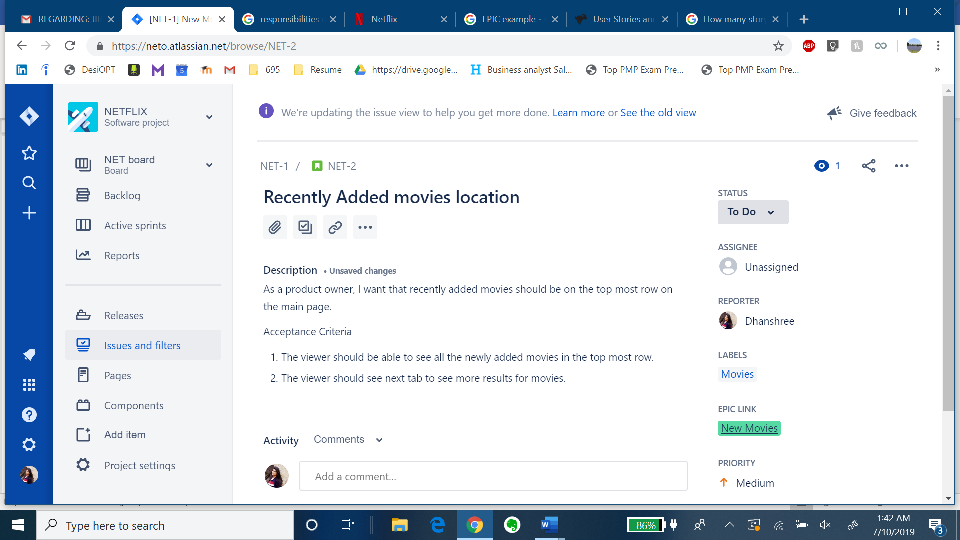

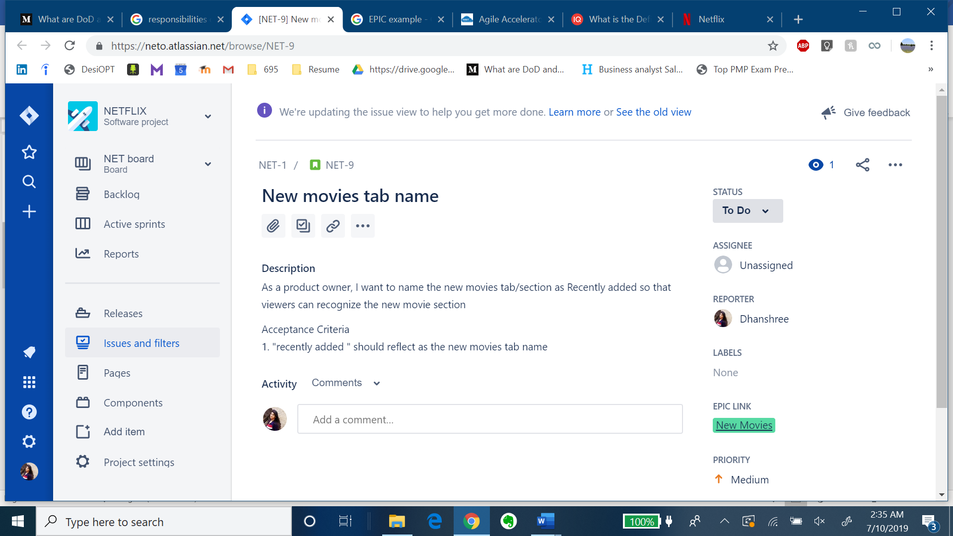

**3.3) Acceptance Criteria**



## **3.4) DOD**

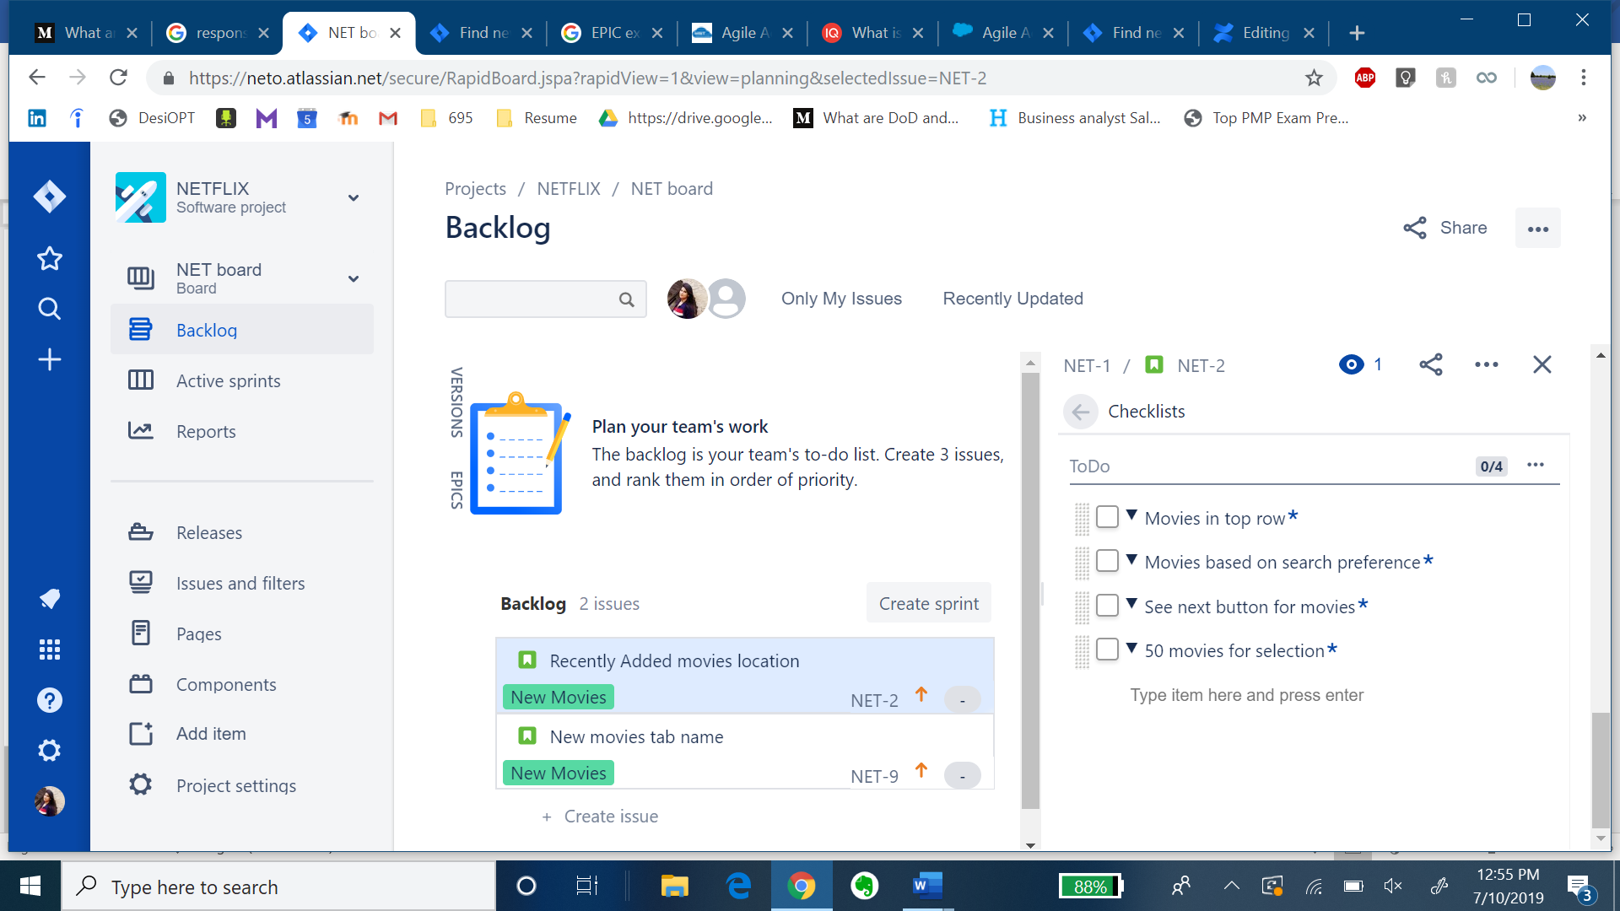

**3.5) Sub-Task if needed**

